South Tippah School District

EDUCATIONAL STABILITY for CHILDREN in
FOSTER CARE
Board Approval Date: June 20, 2023
Implementation Date: July 1, 2023
Superintendent: Tony Elliott
School Board President: Kerry Cockrell
Federal Programs Director: Kelly Gates
Homeless and Unaccompanied Youth Liaison: Kelly Gates

Purpose
The purpose of this document is to outline the procedures used in the South Tippah School District to enroll and withdraw children that have been placed under the care of the Mississippi Child Protection Service.
Goal
South Tippah School District in collaboration with Tippah County Division of Child Protection Services ensures that children placed in foster care have stability with regards to their education.
Definitions
District Point of Contact (DPC) – the person designated by the South Tippah School District Superintendent to represent the District with regards to foster children being enrolled or withdrawn from the district. The District Point of Contact will communicate directly with the Regional Director of Child Protective Services.
School Point of Contact (SPC) – the person designated by the building level Principal to represent the school with regards to foster children being enrolled or withdrawn from the school. The School Point of Contact will communicate directly with the District Point of Contact. The School Point of Contact will ensure that any and all student records are obtained when a foster child enrolls in the local school and that any and all student records are provided to the Child Protective Service Case Work when a foster child withdraws from the local school.
Regional Director of Child Protective Services (CPS) – the person from Child Protective Services that will communicate directly with the District Point of Contact and with the Child Protective Service Case Worker in charge of the case for a particular foster child.
Case Worker – the person from Child Protective Services that has been assigned the case of a child in foster care.
Foster Child – a child to whom the custody has been appointed to Child Protective Services by a sitting judicial authority.
Foster Parent – the parent(s) to whom a foster child is currently residing.
Enrollment of a Foster Child
Resident Foster Children
Foster children residing within the district boundaries shall be enrolled as any other student that resides within the boundaries of the district. The SPC shall obtain any and all records pertaining to the student’s current education. A list of these records is found in Appendix A of this document.
Following the enrollment of the student the SPC will complete the enrollment document placing a copy on file in the office of the SPC while forwarding the original to the DPC. The DPC will keep on file the original until the student withdraws, graduates from the South Tippah School District, or the child is no longer in the care of Child Protective Services.
Non-Resident Foster Children
Foster children not residing within the district boundaries shall be enrolled once a determination has been made that it is in the best interest of the child to attend a school within the South Tippah School District. The DPC in collaboration of CPS will meet with the SPC, Principal, Parents (if allowed), Foster Parents, and other interested parties. The meeting shall take place within 3 business days after CPS has sought to enroll the child in the South Tippah School District or prior to CPS seeking enrollment in the South Tippah School District.
A determination as to whether or not it would be in the best interest of the child to attend the school in the South Tippah School District shall be made immediately following this meeting.
The South Tippah School District recognizes the right of a foster child to attend the child’s school of origin provided that it is reasonable.
Withdrawal of a Student by CPS
CPS has the right to withdraw students assigned to them by a judicial authority. The SPC in this case is responsible for providing as many educational records as possible to make any transition from the school of origin to the new school a smooth transition. Records not on file in the school office shall be forwarded the new school within 24 hours following a request by the school or CPS.
The SPC shall contact the DPC if he/she thinks it would be in the best interest for the child being withdrawn to remain in the school of origin. The DPC will immediately contact the Regional Director of Child Protective Services to relay the concerns of the SPC as well as possibly scheduling a time to discuss the child’s educational placement.

Free/Reduced Lunch Application
Foster Care Parents or Child Protective Services should complete a Free/Reduced Lunch Form for the South Tippah School District. The form along with verification of foster care shall be submitted to the School Point of Contact who in turn will forward the documents to the District Point of Contact. The District Point of Contact will forward the documents to the Food Service Director or Food Service Secretary.

Best Interest Determination Form
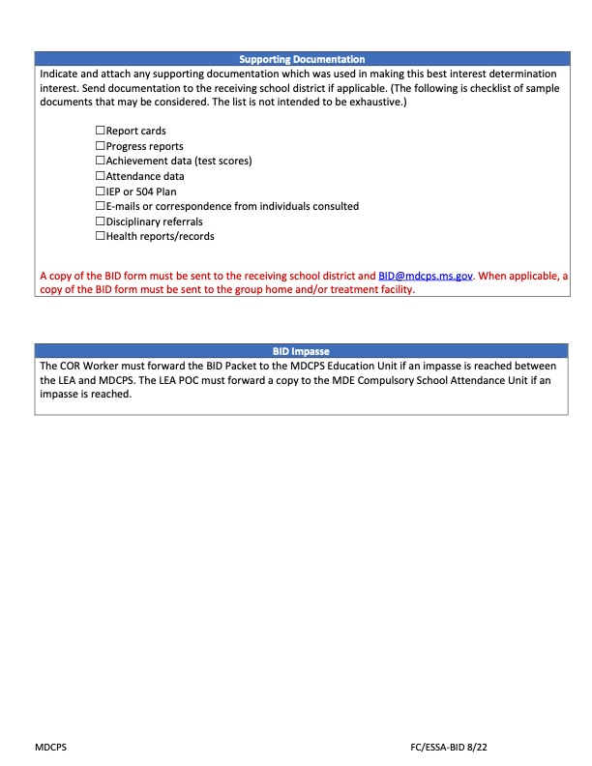
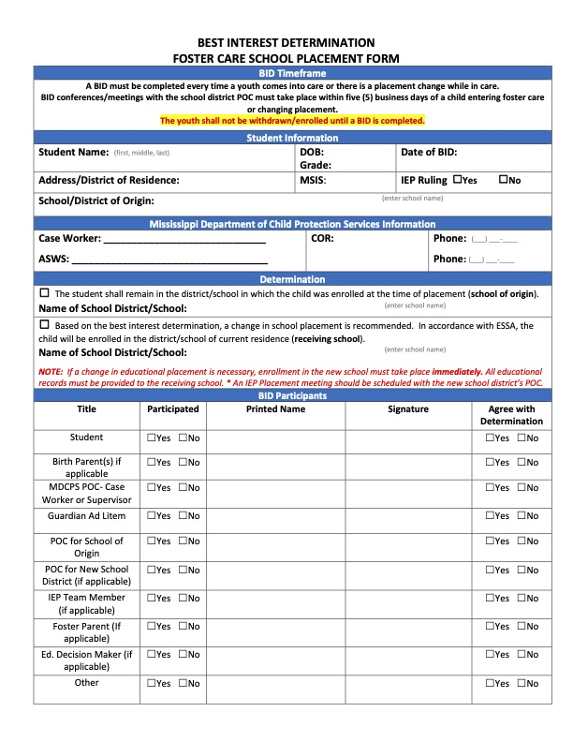

South Tippah School District
Transportation Agreement Form (page 1 of 2)
Child’s Name: _________________________________ DOB: ____________ Grade: _____
MSIS ID: _________________________________
Custodial Agent Caregiver (Name and Contact Information):
____________________________________________________________________________
______________________________________________________________________________
Caregiver (Name and Contact Information):
______________________________________________________________________________
______________________________________________________________________________
Educational Representative, if applicable (Name and Contact Information:
______________________________________________________________________________
______________________________________________________________________________
District: _______________________________________________
District Foster Care Point of Contact (Name and Contact Information):
______________________________________________________________________________
______________________________________________________________________________
Case Worker (Name and Contact Information):
______________________________________________________________________________
______________________________________________________________________________
The custodial agency verifies that:
1. It is in the student’s best interest to remain in the school of origin based on the following factors:
______________________________________________________________________________
______________________________________________________________________________
2. Eligibility of the child under Title IV-E from the Mississippi Department of Child Protection Services: _____ Yes _____ No
a. If YES, reimbursement for some funding of transportation costs:
______ will be pursued
______ cannot be pursued for the reason below:
______________________________________________________________________________
Transportation Agreement Form (page 2 of 2)
3. The following was executed to identify a no-cost or low-cost transportation service:
The district verifies that: ______________________________________________________________________________
______________________________________________________________________________
4. There is an existing transportation option that can server the student’s new housing placement.
_____ Yes _____ No
If YES, explain the option: ______________________________________________________________________________
______________________________________________________________________________
The District and Mississippi Child Protection Services agree that the most cost effective transportation procedures for this student will be:
______________________________________________________________________________
______________________________________________________________________________
The District and Mississippi Child Protection Services agree that while permanent transportation is arranged, interim transportation arrangements will be:
______________________________________________________________________________
______________________________________________________________________________
These transportation procedures were agreed to on the following date: ___________________ and will be implemented within five (5) days, by the following date: ______________________.

______________________________________ ________________________
Authorized Signature Date
Mississippi Child Protective Services

_______________________________________ ________________________
Signature Date
LEA Foster Care Point of Contact

Dispute Resolution to State Level Point of Contact

To appeal the district's decision to the Mississippi Department of Education and
Mississippi Department of Child Protection Services, please complete this form and
submit it by the date indicated on the Written Notice you received from the school. You
may submit this form by any of the following methods:

- Scan and email it to TWilliams@mdek12.org with the subject "Foster Child Dispute
Appeal" to Terissa Williams, Mississippi Department of Education, Foster Care Point of
Contact;
OR
- Return the paper form to Terissa Williams, Mississippi Department of Education, Foster Care Point of Contact at 359 N. West Street, Jackson, MS 39201
Student Name: _
School in which enrollment is sought: __________________________________________
I am the educational decision-maker for this student, and I believe the school in which we
are seeking enrollment is in the student's best interest because:
I believe the student has a right to attend this school because: ________________________________________________________________________________________________________________________________________________________________________________________________________________________________________________________________________________________________________If you would like to provide additional information, please attach it to this form. The
student shall remain in the school of origin, receiving all appropriate educational services
including transportation, until the dispute reaches its final resolution.
Educational decision-maker name: ________________________________
Email: ____________________________________________________________________
Phone:

Appendix A
Children in Foster Care Enrollment
Records Checklist

The following records are required for enrollment of a child in foster care.

Supporting Documentation:
- Report Cards and Progress Reports

- Discipline Records

- Student Achievement

- Teacher Evaluations

- Attendance Records

- Written input from absent participants

- IEP and/or 504 Plan

- Transcript showing current credits, if high school student

- Withdrawal from Previous School

- Copy of Birth Certificate

- Copy of Immunization Form

- Other: __________________________________________________________________

